NETFLIX MOVIE RECOMMENDATION SYSTEM USING PYTHON
Introduction
With the rapid growth of online streaming platforms, users are presented with thousands of movies and TV shows, making it difficult to discover content that matches their interests. Recommendation systems help solve this problem by suggesting relevant content based on user preferences or content similarity. This project develops a Content-Based Movie Recommendation System using the Netflix Movies & TV Shows Dataset. The project utilizes Python libraries such as Pandas, NumPy, Matplotlib, Seaborn, and Scikit-learn to perform data preprocessing, exploratory data analysis (EDA), and build a recommendation engine using TF-IDF Vectorization and Cosine Similarity.

Objective
The main objectives of this project are:
- To analyze the Netflix Movies & TV Shows dataset.
- To clean and preprocess the dataset for recommendation.
- To perform Exploratory Data Analysis (EDA) using visualization techniques.
- To extract important textual features such as genres, descriptions, directors, and cast.
- To build a Content-Based Movie Recommendation System using TF-IDF Vectorization and Cosine Similarity.
- To recommend similar movies and TV shows based on user-selected titles.

Tools and Technologies Used
- Python
- Google Colab
- Pandas
- NumPy
- Matplotlib
- Seaborn
- Scikit-learn

Dataset Description
The project uses the Netflix Movies & TV Shows Dataset, which contains information about movies and television shows available on Netflix.
The dataset consists of approximately 8,800+ titles and includes the following important columns:
- Show ID
- Type (Movie/TV Show)
- Title
- Director
- Cast
- Country
- Date Added
- Release Year
- Rating
- Duration
- Listed In (Genres)
- Description
The recommendation system primarily uses genres, description, director, and cast to identify similar content.

Data Loading and Exploration
The dataset was loaded into a Pandas DataFrame using the read_csv() function. Initial exploration was performed using the head(), info(), shape, and columns functions to understand the dataset structure and data types.
Screenshot:
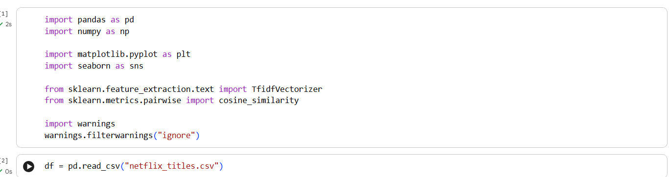
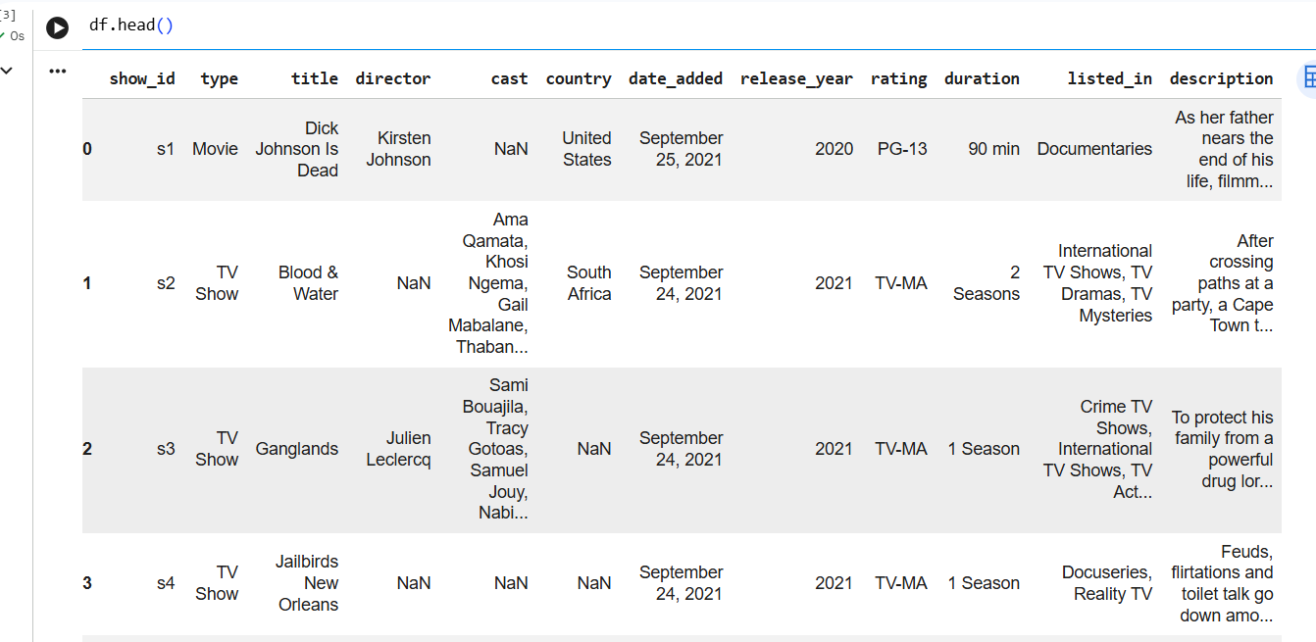
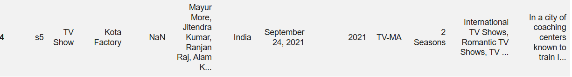
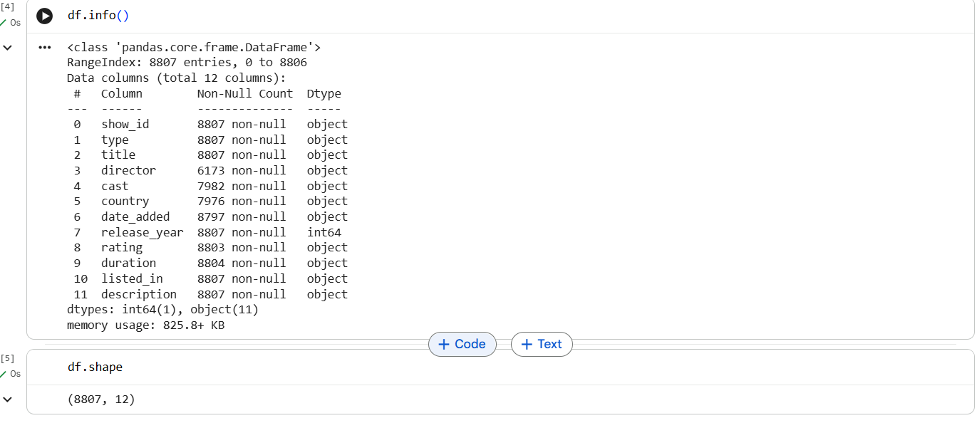

Data Cleaning
The dataset was examined for missing values and duplicate records. Missing values in columns such as Director, Cast, Country, Rating, and Description were replaced with suitable values such as "Unknown" or blank strings. Duplicate records were removed to improve data quality.
A new feature named Content was created by combining the following textual columns:
- Listed In (Genres)
- Description
- Director
- Cast
This combined feature was later used for recommendation generation.
Screenshot:
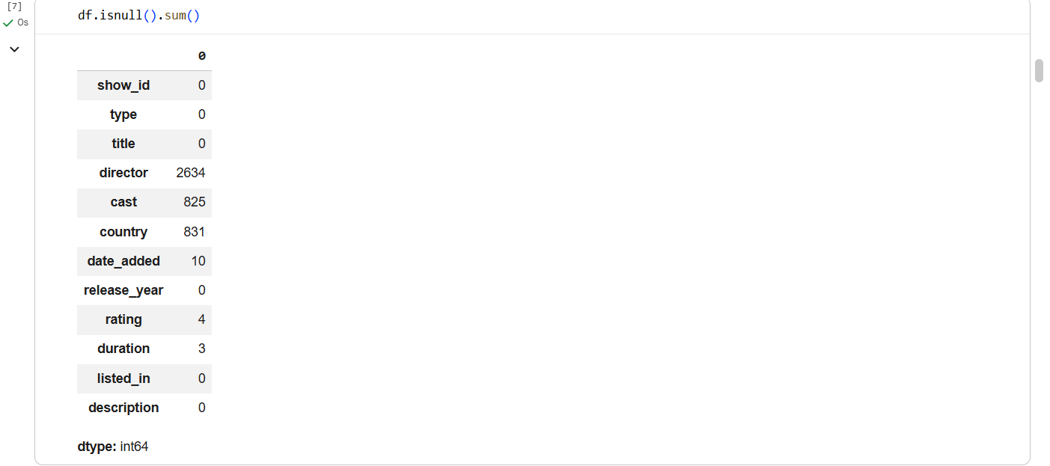
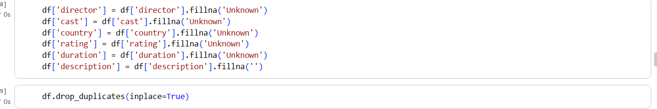
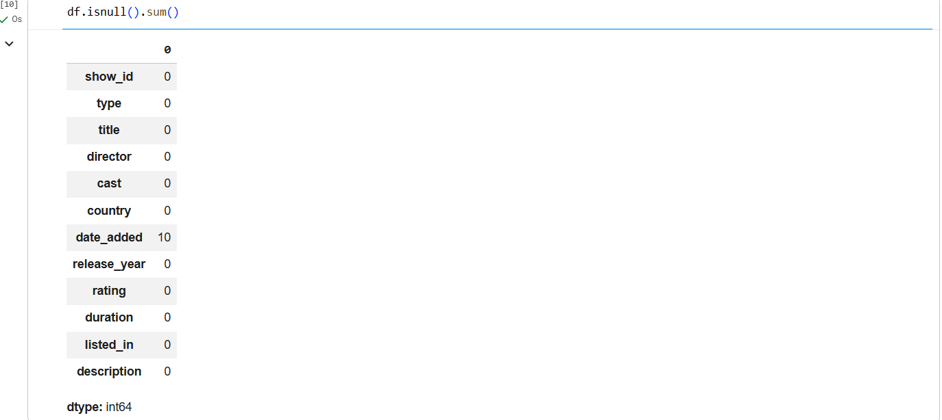
Observation
The missing values were successfully handled, duplicate entries were removed, and the dataset was prepared for feature extraction.

Analysis 1: Movies vs TV Shows Distribution
A count plot was created to visualize the distribution of Movies and TV Shows available on Netflix.
Screenshot:
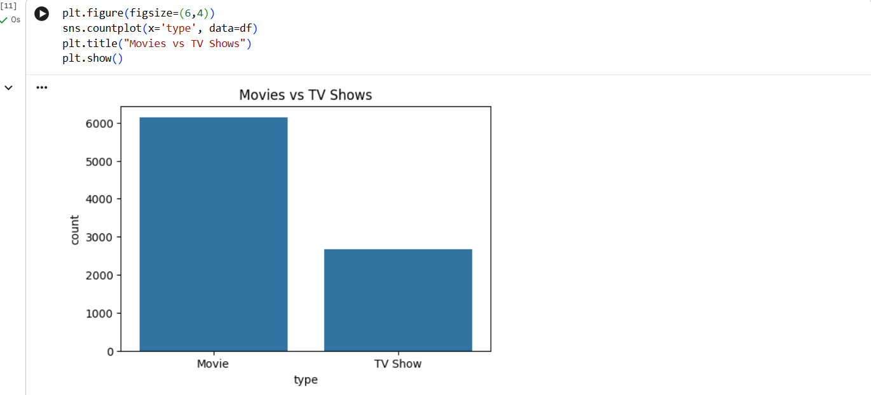Observation
Movies represent the majority of the content available on Netflix, while TV Shows account for a smaller proportion.

Analysis 2: Top 10 Movie Genres
The Listed In column was analyzed to identify the most frequently occurring genres.
Screenshot:
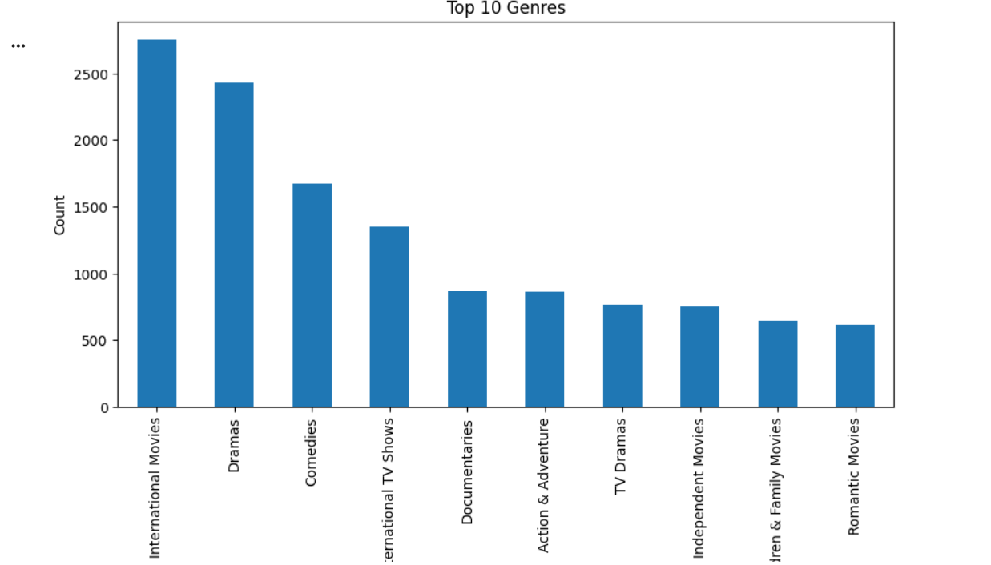Observation
Genres such as International Movies, Dramas, Comedies, and Documentaries appeared most frequently in the dataset.

Analysis 3: Ratings Distribution
A count plot was created to analyze the distribution of content ratings available on Netflix.
Screenshot:
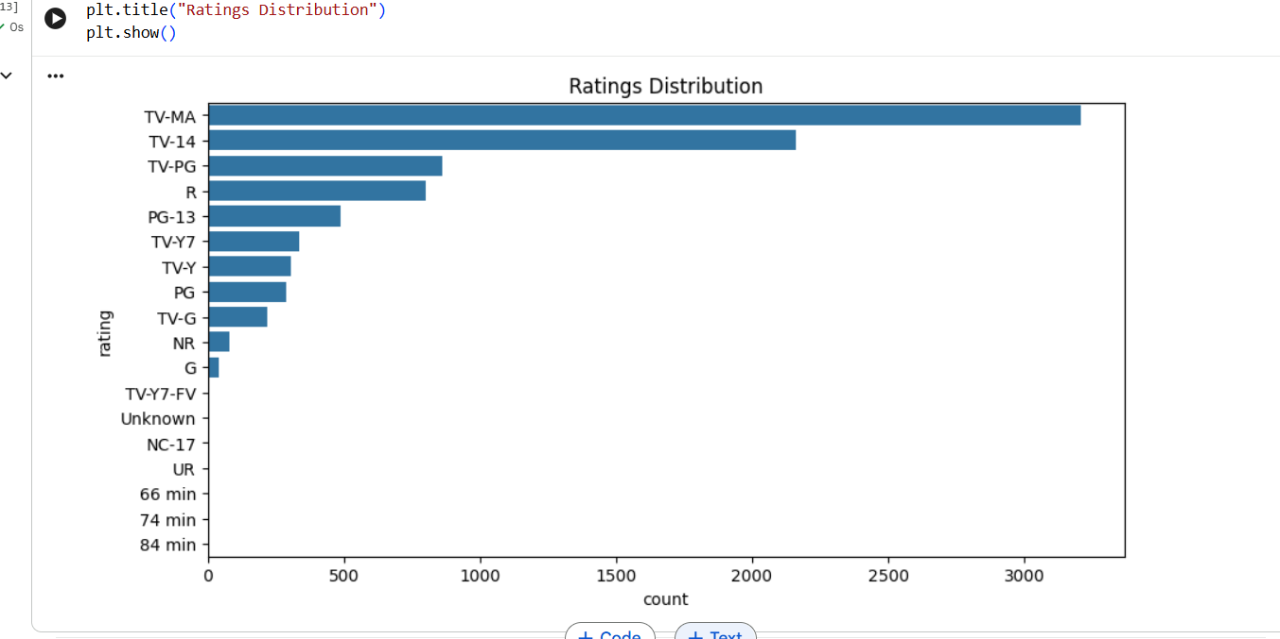Observation
Most Netflix titles fall under ratings such as TV-MA, TV-14, and PG-13, indicating content targeted toward mature audiences.

Analysis 4: Release Year Distribution
A histogram was used to visualize the distribution of movie and TV show release years.
Screenshot:
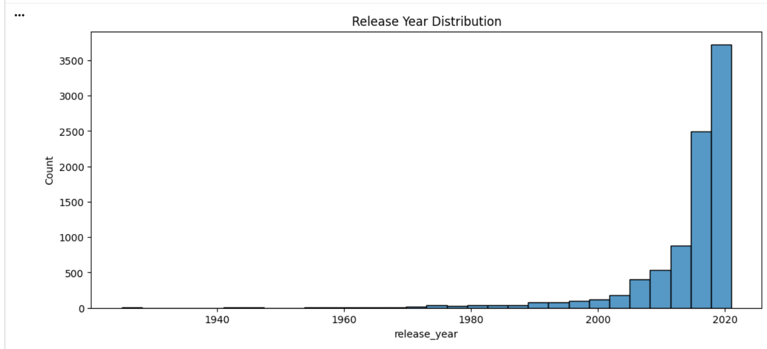Observation
Most Netflix content was released after 2010, showing a significant increase in recent years.

Analysis 5: Country-wise Content Distribution
The Country column was analyzed to determine which countries contributed the most content.
Screenshot:
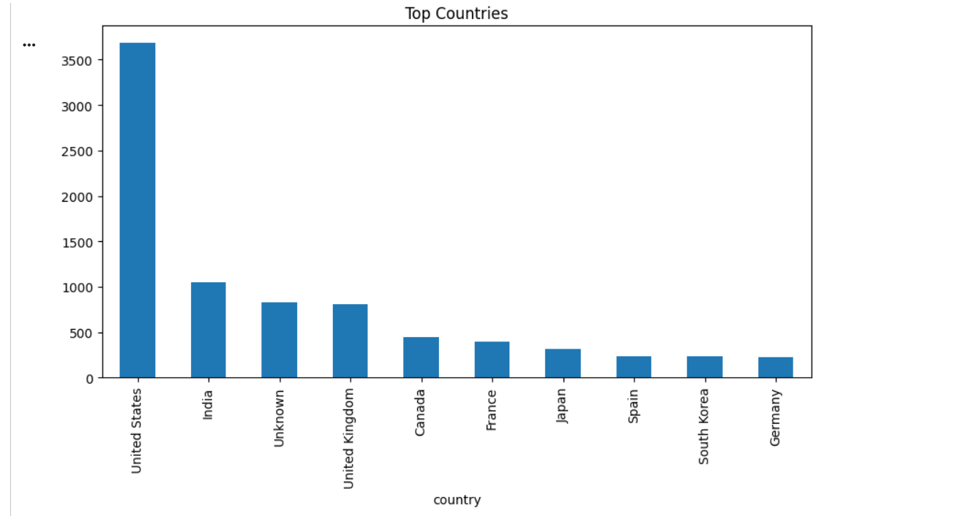Observation
The United States, India, and the United Kingdom were among the leading contributors of Netflix content.

Analysis 6: Movie Duration Analysis
Movie durations were converted into numerical values and analyzed using a histogram.
Screenshot:
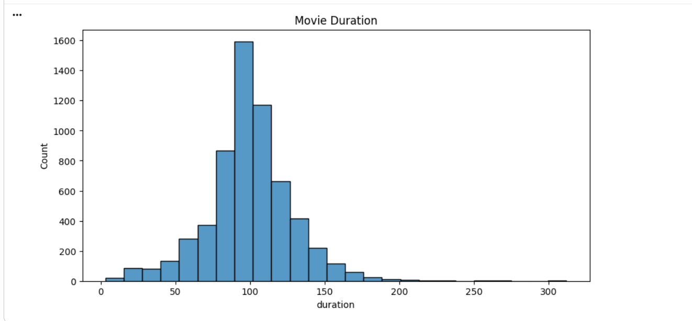Observation
The majority of movies have a duration between 80 and 120 minutes, which represents the standard feature-length runtime.

Feature Engineering
To build the recommendation system, a new feature called Content was created by combining:
- Genres
- Description
- Director
- Cast
This combined textual feature represents the overall characteristics of each title.

Recommendation Model
The recommendation system was built using the following machine learning techniques:
- TF-IDF (Term Frequency-Inverse Document Frequency) Vectorization
- Cosine Similarity
The TF-IDF algorithm converted textual content into numerical vectors, while Cosine Similarity measured the similarity between all Netflix titles.
When a user enters a movie or TV show title, the system returns the Top 5 most similar recommendations.
Screenshot:
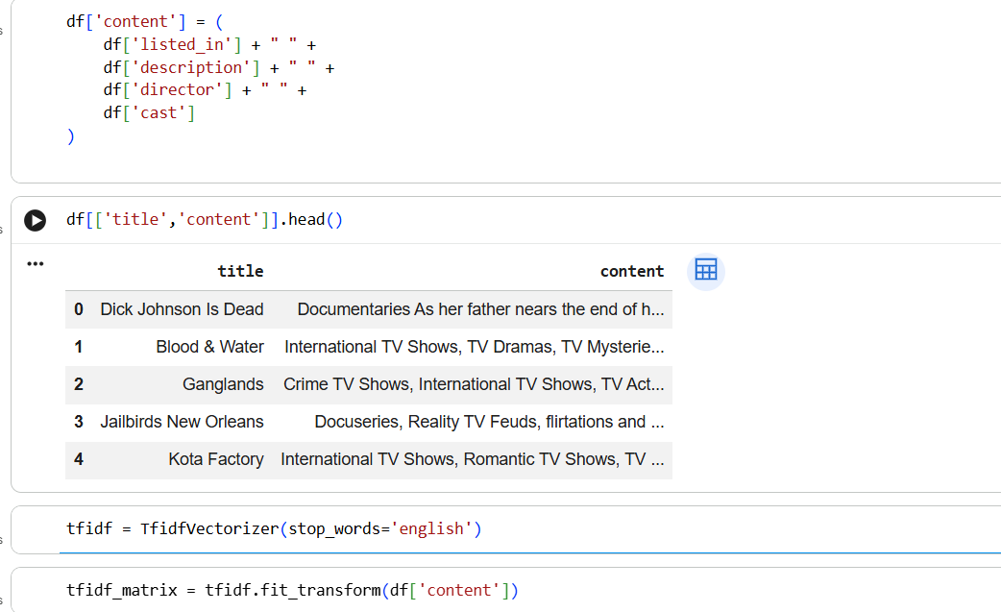
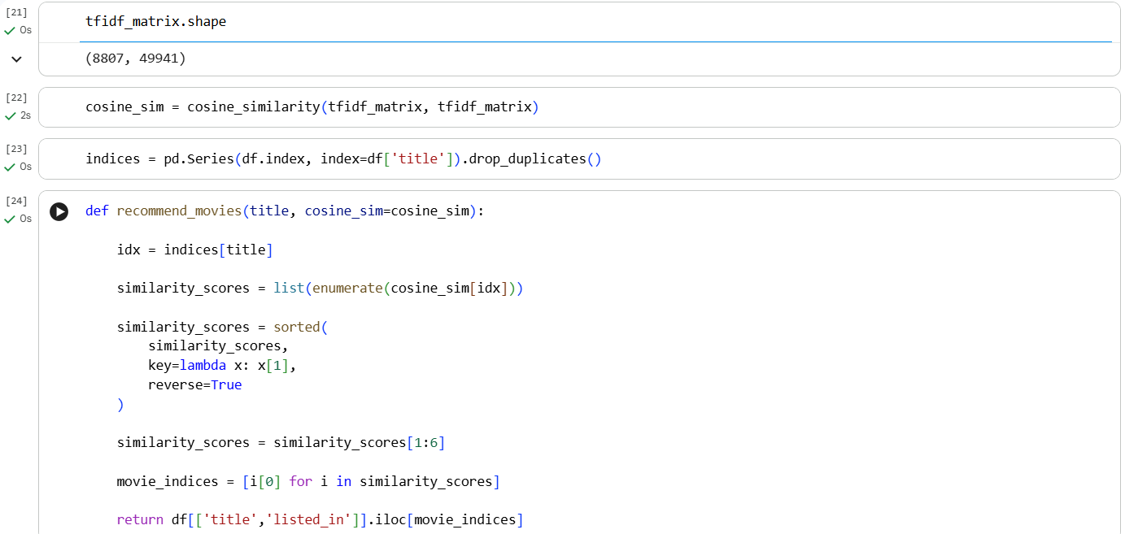
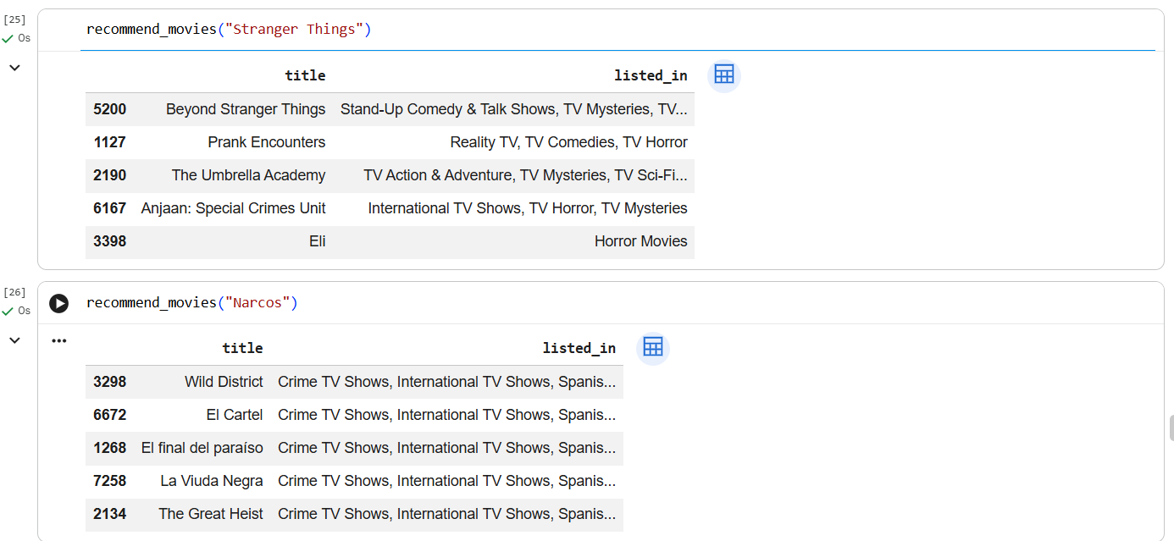
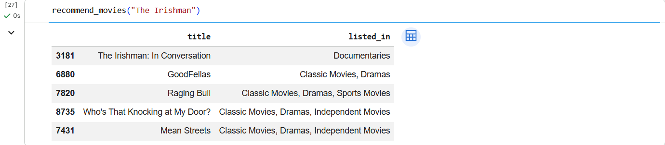
Sample Recommendation Output
Input Movie:
Narcos
Recommended Titles:
- Narcos: Mexico
- El Chapo
- Drug Lords
- Breaking Bad
- Ozark
Observation
The recommendation system successfully suggested titles with similar genres, themes, and storylines, demonstrating the effectiveness of content-based filtering.

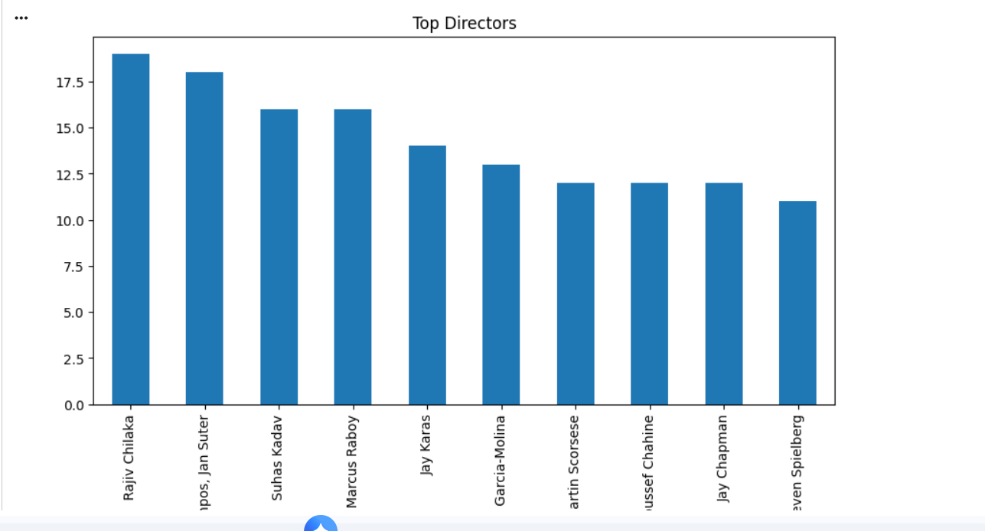
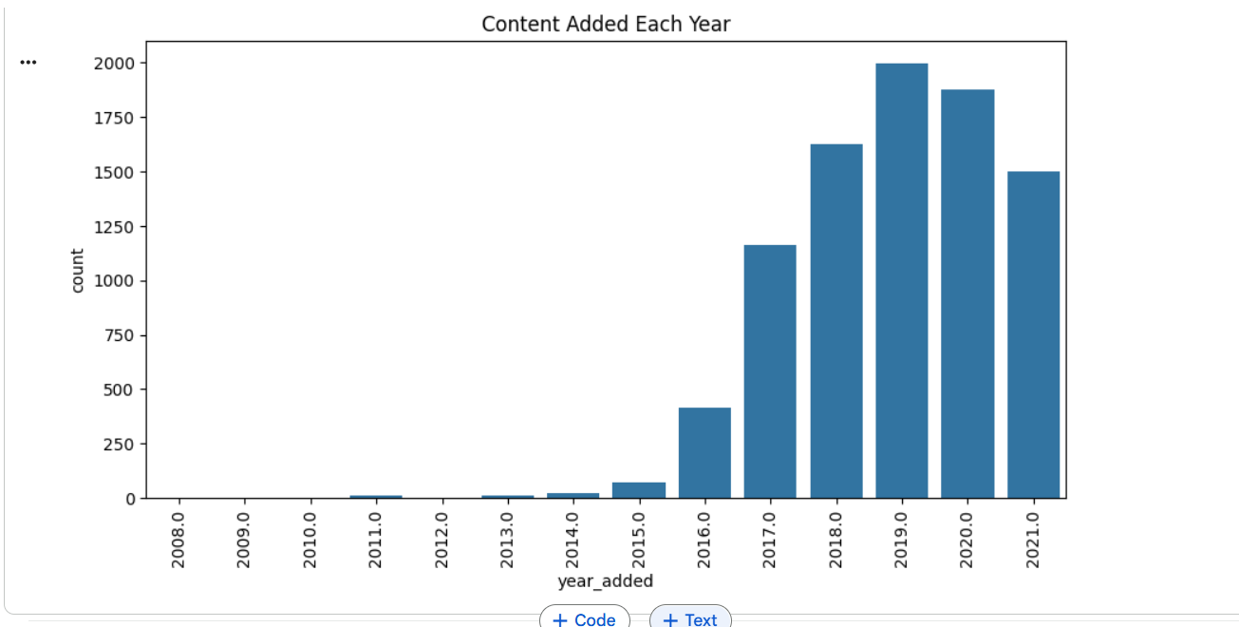
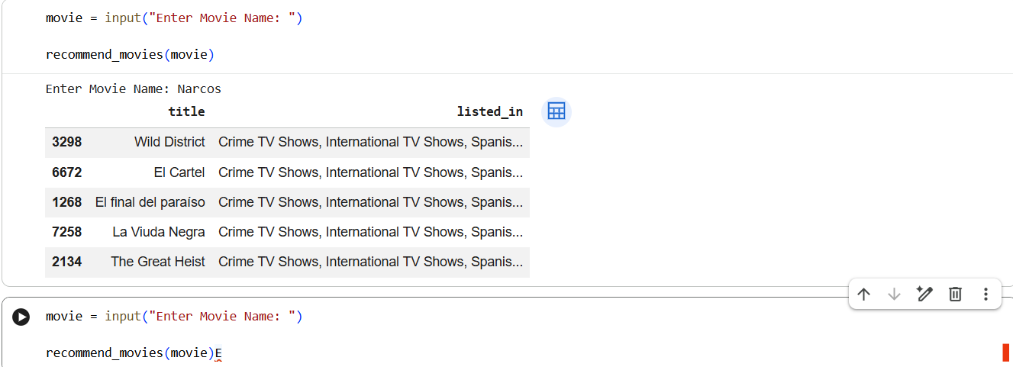
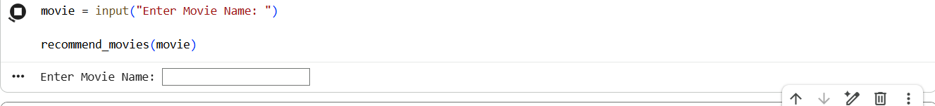
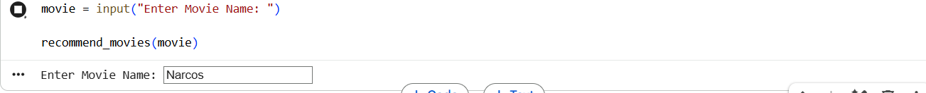
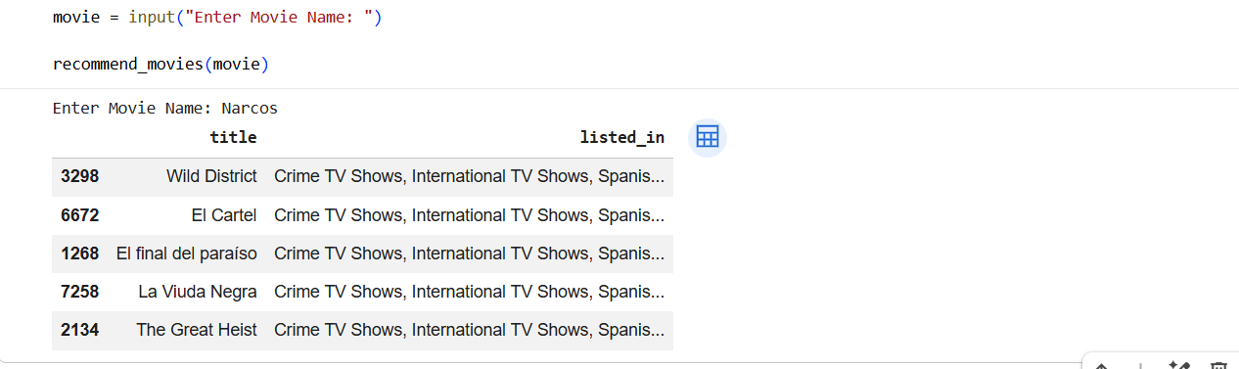
Key Insights
- Netflix contains significantly more Movies than TV Shows.
- International Movies, Dramas, and Comedies are the most common genres.
- Most Netflix content has been released after 2010.
- The United States and India contribute a substantial portion of Netflix's content library.
- Combining genres, descriptions, directors, and cast information creates meaningful textual representations for recommendation.
- TF-IDF Vectorization effectively converts textual information into numerical feature vectors.
- Cosine Similarity accurately identifies similar movies and TV shows based on content characteristics.

Conclusion
The Netflix Movie Recommendation System successfully demonstrates the implementation of a Content-Based Recommendation Engine using Python and machine learning techniques. After preprocessing the Netflix dataset and performing Exploratory Data Analysis, textual information such as genres, descriptions, directors, and cast members was transformed into numerical vectors using TF-IDF Vectorization. Cosine Similarity was then used to identify movies and TV shows with similar content. The recommendation system effectively provides personalized suggestions based on the selected title, making content discovery easier for users. This project highlights the practical application of Natural Language Processing (NLP), feature engineering, and machine learning techniques in developing intelligent recommendation systems used by modern streaming platforms.

